Vehicle Dimensions

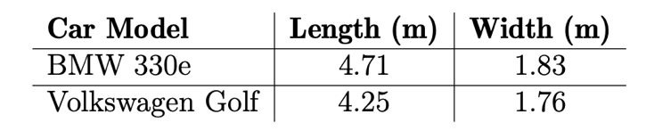
(from table 3.3)

Speeds

All tested ground-truth speeds:
- 20 km/h
- 30 km/h
- 40 km/h
- 50 km/h
Speeds were taken from the dashboard speedometer, serving as the ground-truth reference.

(from section 6.1.2)

Reference Points (for Homography Calibration)

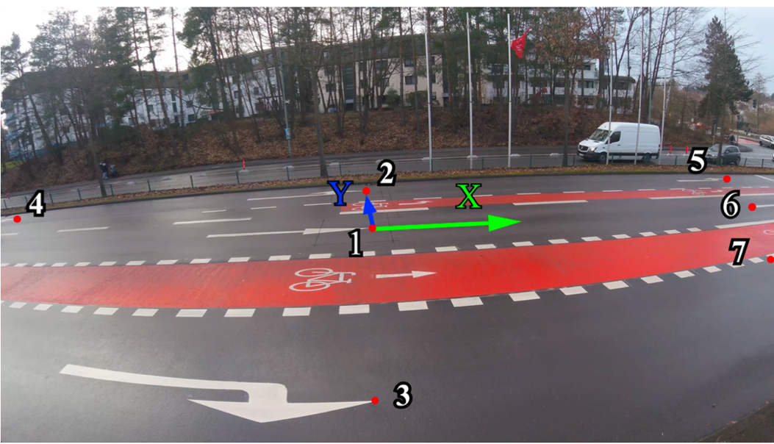
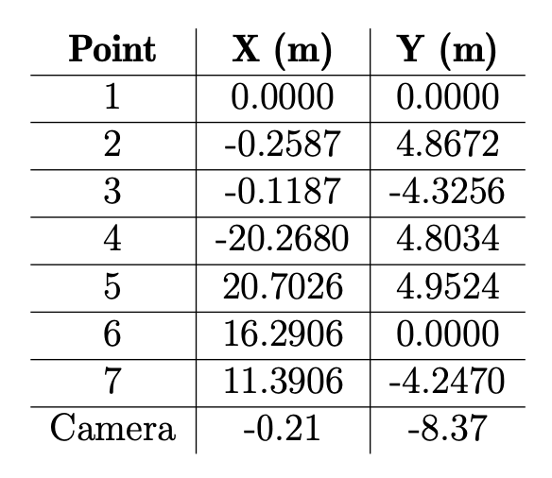

(from table 3.2)
Conditions

Camera setup
- Camera model: GoPro Hero 5 Session
- Height above ground: 3 meters
- Orientation: Perpendicular to vehicle path

Recording environment
- Straight road
- Normal daytime lighting
- Vehicles driven manually at constant preset speeds

Camera Calibration

- Intrinsic matrix(K)
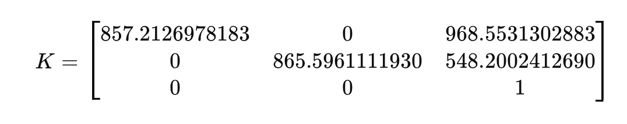
- Distortion co-efficients (D)
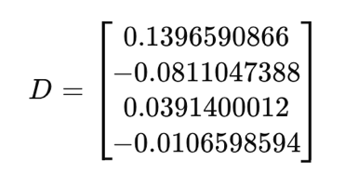
- Calibrations details
Resolution: 1920 x 1080
RMS error: 0.7324

(from gopro_calibration_fisheye.npz)

